Resolving Eduroam connection issue on iPad and iPhone
If your iPhone or iPad is persistently failing to connect to the Eduroam Wi-Fi network please use the following steps to resolve the issue:
- Select Settings.
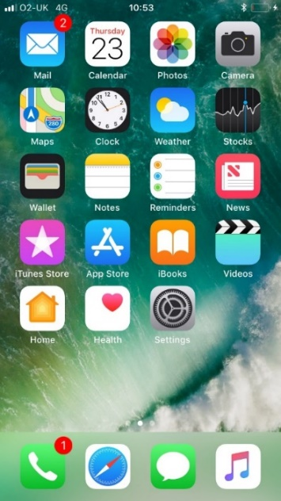
- Select Wifi

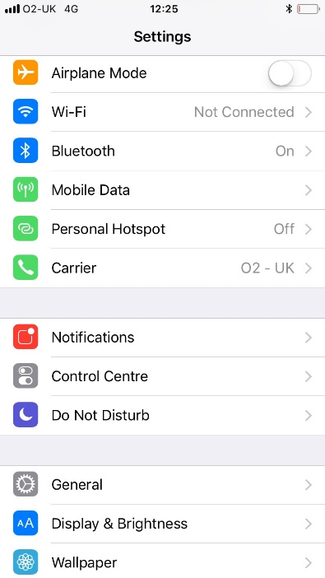
- Next to Eduroam, click on icon.

- 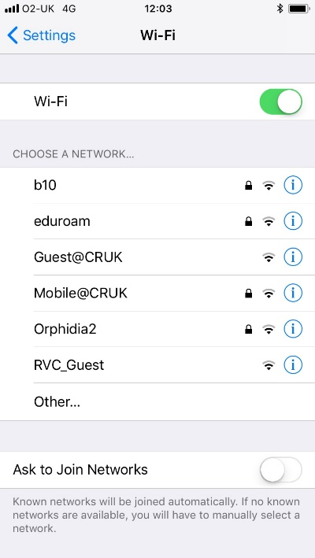

- Select Forget This Network (if it is available)

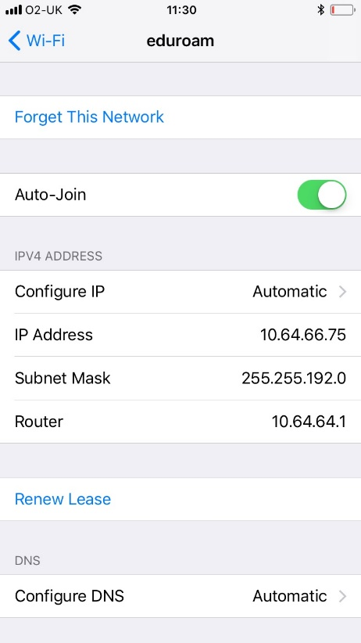
- Back on Setting, select General

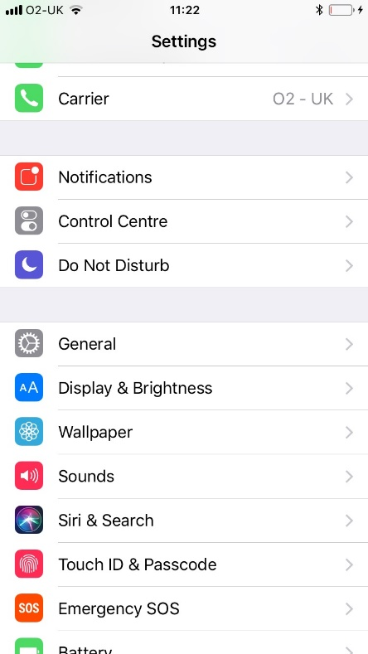

- Select Profiles (if exist ) then remove Eduroam profile

- Under General, select Reset

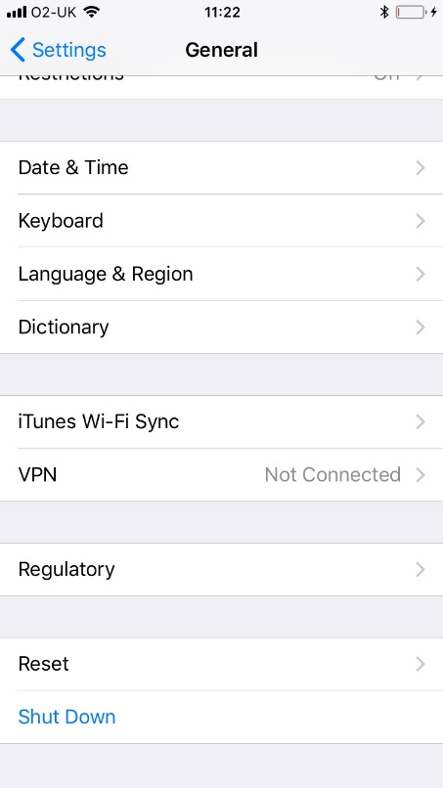
- Select Reset Network Settings

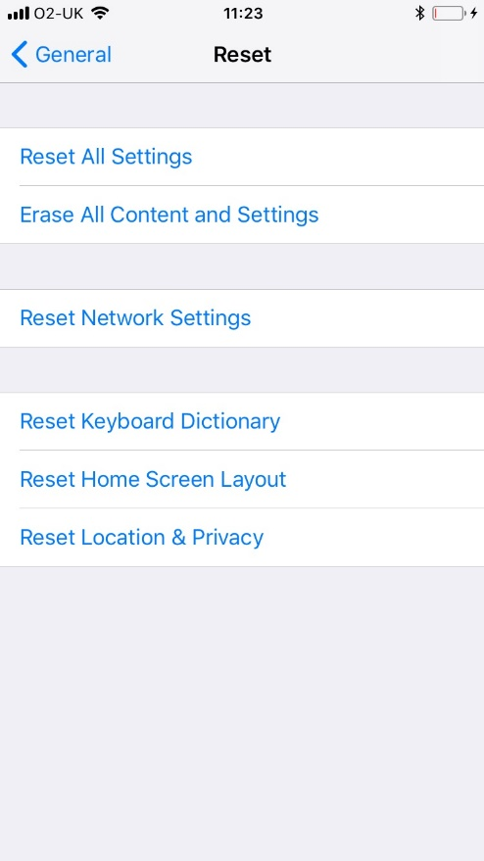

- Select Reset Network Settings

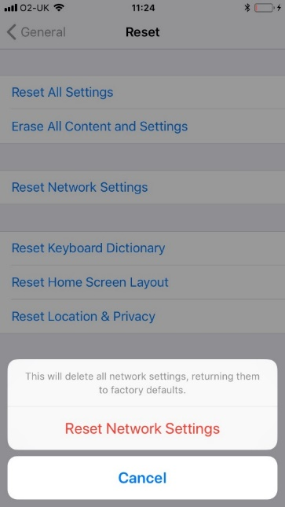
- Enter your passcode to confirm. Your device will now restarts.

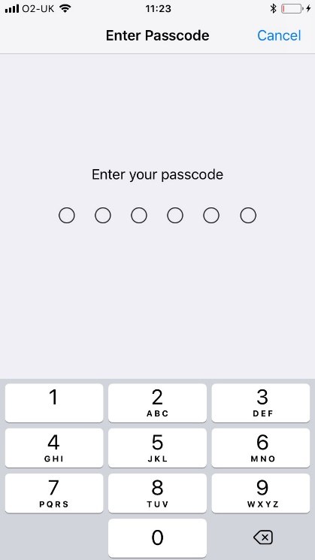

- Now select eduroam and enter your credentials with the following format:

username@rvc.ac.uk

- You will be asked to Trust the certificate as below. You should now have eduroam working.

- 