Resolving Eduroam connection issue on MacBook
If your Mac is persistently failing to connect to the Eduroam Wi-Fi network please use the following steps to resolve the issue:

- Click the “Apple” menu, “System Preferences”, “Network”, “Advanced”, under wifi tap, select Eduroam (if available) and remove

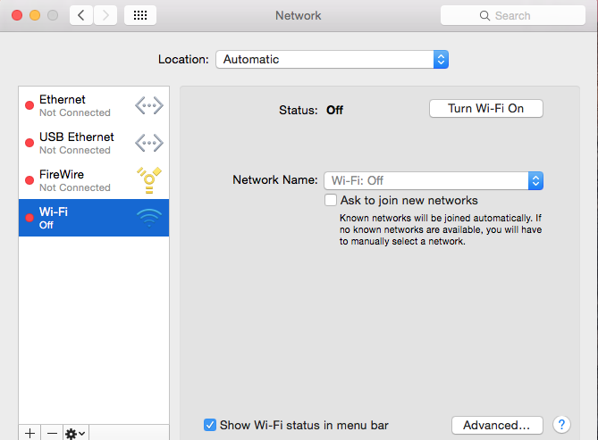
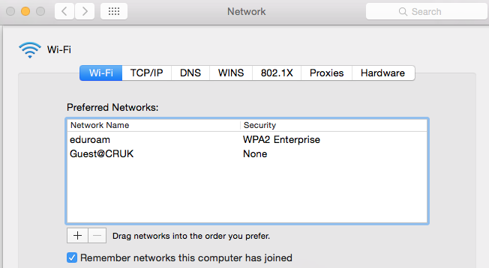

- Click the “Apple” menu and choose “System Preferences”, if Profiles option is available, then please double click and remove eduroam (see the screenshot below)

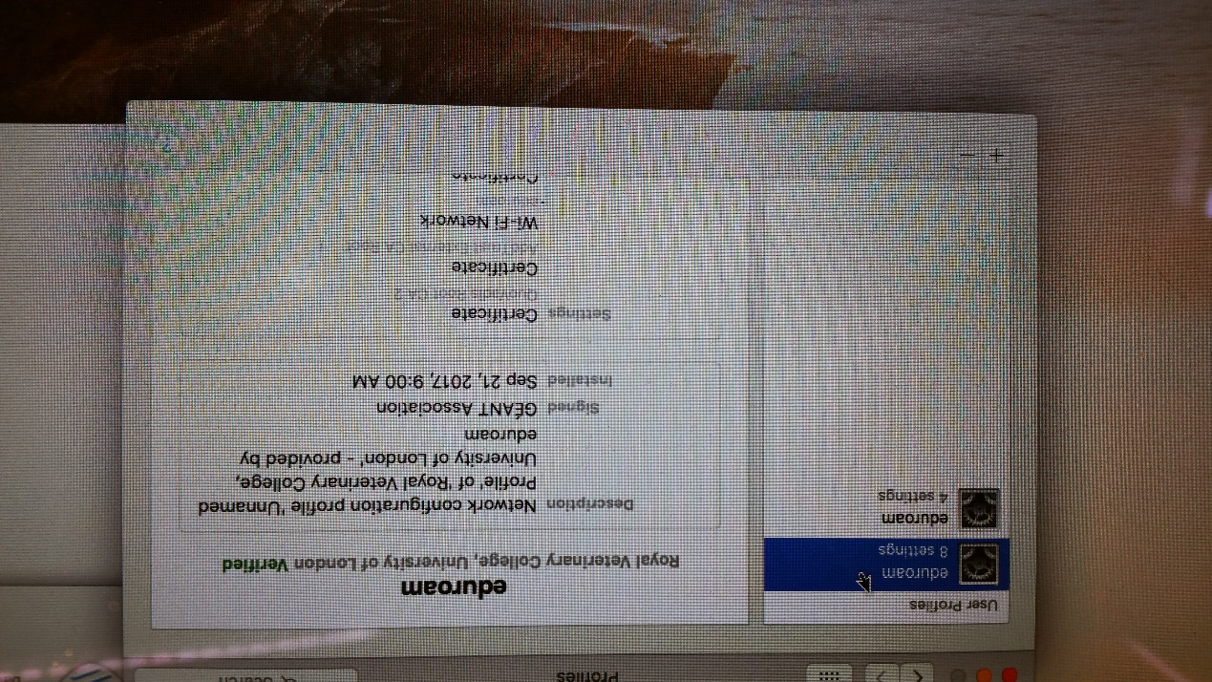

- Click on the magnifying glass in the top right corner of the screen.

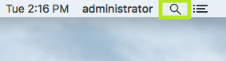

- Type Keychain Access

- Now search the followings and delete if exist in the keychain

- cmcise.rvc.ac.uk
- hhcise.rvc.ac.uk
- eduroam

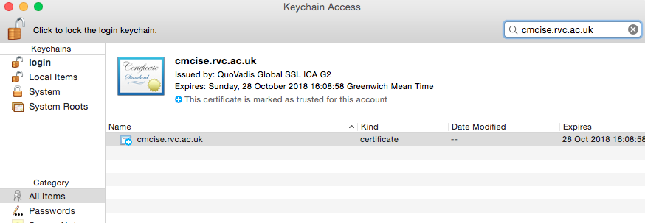

-On the menu bar, select GO

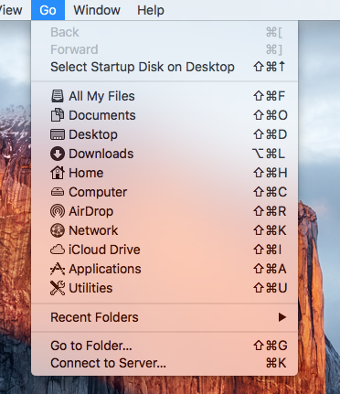

- Select COMPUTER
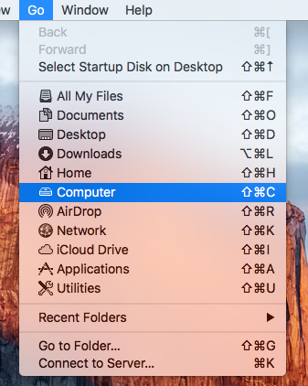

- Go to Library – Preferences – SystemsConfiguration ( see the screenshot below)
- Select
- com.apple.airport.preferences.plist
- com.apple.captive.probe.plist
- com.apple.eapolclient.plist
- com.apple.network.eapolclient.configuration.plist
- NetworkInterfaces.plist
- Prefrences.plist
Copy them to desktop for backup first, and then delete the highlighted files.
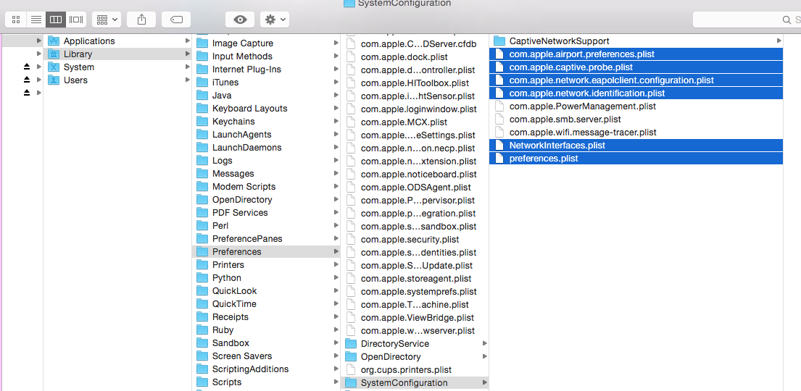

- Restart MAC and select Eduroam, enter your credentials with the following format:

username@rvc.ac.uk or just username (please try on each format)

. Select Continue to verify and install the certificate.

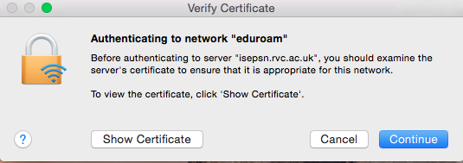

Eduroam should now be connected

