Using RVC Learn Grades
RVC Learn contains a “Grades” section for each course which tracks your scores in RVC Learn MCQs and quizzes. The Grades section can be used to view all your quiz scores and gives you quick access to review quizzes that have been completed.
The Grades section is an excellent tool to use for revision – all the scores are displayed on one page, making it easy to identify your weaker subject areas. Links to all the MCQs on a course are accessible via the Grade section.
To access your RVC Learn Grades section
- Login to RVC Learn and go to the course that you wish to review your grades.

- Click on the Grades icon, located in the Settings menu, on the left hand side of the screen.

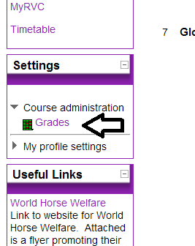

3. A list of all the quizzes from the course, detailing each grade you have received.
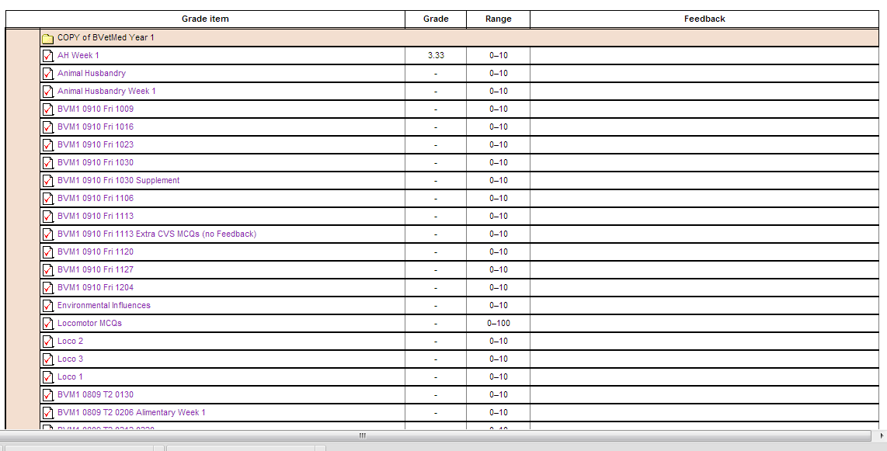

4. To review a quiz, simply click on the name on the quiz.

5. Then click on Review, or Re-attempt quiz, if you would like to re-atttempt the quiz.

