Infrastructure Services: Library and IT Update
Autumn 2017

Welcome to the autumn edition of the Library and IT Newsletter in which we tell you about things we have done during the spring and summer to improve our services to you. There are tips and pointers about some of the new services and guidance about who to speak to find help, give us feedback and to book training. There is even a quiz to keep you entertained. We are always very happy to hear from our users directly so do contact us if you would like to make suggestions about how we could improve things.

Library Books: You Say We Pay

Library & Information Services has established a book fund for students, which will be used solely to add extra copies or titles to our collections. You can ask us to buy books and we will do so, no questions asked so you will never need to worry about too few copies of textbooks!
To request books email wepaybooks@rvc.ac.uk with all the details.

Services to new students

With the new term approaching we in the library team are preparing to welcome new and returning students. We have been working hard to make the learning environment at the RVC better than ever!

Michael Murphy has been working on creating online introductions to IT at the college to help students become more familiar with our resources in their own time https://learn.rvc.ac.uk/course/view.php?id=1171 We are also enriching student learning by further integrating Lynda.com into the available library resources. We are keen ambassadors of this fantastic tool and we will be helping our users to make it a part of their regular library use. More on these items later in the newsletter.

Several staff have attended Endnote training so that they can show our students how to get the most out of this reference management software. If you would like to book a training session, please contact Anna Griffiths agriffiths@rvc.ac.uk at Hawkshead or Michael Murphy mmurphy@rvc.ac.uk at Camden.

SCOUT

The Library has implemented a new version of SCOUT over the summer, which you can find at www.rvc.ac.uk/library . It looks different, but works in a similar way and there should be quicker access to e-resources. There is still a database list at the top right of the screen and a combined Journal & eBook A-Z just above the Library Twitter feed.

You can access your library account by going to log in and using your RVC userid and password, then clicking on My Account, there you can see the books you have out, view holds and renew books.

If you have any questions, please contact library@rvc.ac.uk .

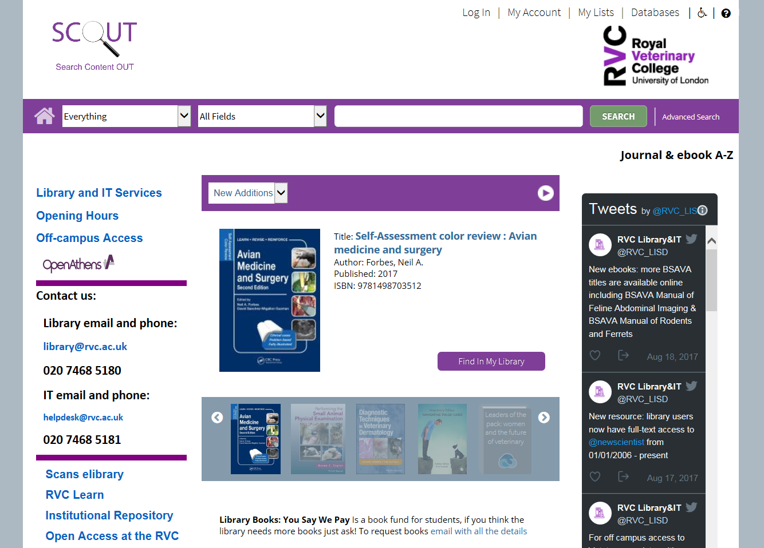

Camden developments

Work is underway at Camden on the new and improved library facilities. We hope the new space will be more welcoming and contain more study spaces to help the library become a real hub of learning and activity.

We want to capitalize on all of these fantastic new developments and will be working hard to engage with you about how you like to learn and what you expect from your library and IT services. Please let us know of any possible further improvements we can make to our service. It is an exciting time and we can’t wait to kick off the new term in the new space which will be ready in October.

Online Induction on Learn

The LISD and eMedia team have developed a new online induction course on Learn, to introduce new students to the services and resources offered by the Library and IT departments at the RVC. The course can be viewed here – https://learn.rvc.ac.uk/course/view.php?id=1171 – and completed at your own pace. Please direct any comments, corrections or compliments to Michael Murphy mmurphy@rvc.ac.uk

Library Elf is a web-based and email tool for Library users, making it easier to keep track of what's due, overdue or ready for pickup from the Library. Registration is free; the link is on the LISD Intranet page and the Library Catalogue page.

Apogee Managed Print Service

We are now entering our fourth year of our managed printing contract with Apogee (company was previously called Danwood) and during that time the service provided by the MFD devices located around the campus has proven to be a great success.

During the first three years by using the managed print service, we have saved 475204 pages of B/W pages and 286285 colour pages from being printed. This has amounted to a saving of over 28 trees and over 13071kg of C02.

For those students who are joining us this year the service is easy to use and when printing you should see two queues that you can choose from called either Camden_B&W_MFD or Camden_Colour_MFD (Camden) or Hawkshead_B&W_MFD or Hawkshead_Colour_MFD ( Hawkshead). The system will also allow you to send a job to your default queue and then pick up your printing from one of the MFD devices at the other campus.

Once you have sent your document to print, please go along to one of the many MFD devices that are located around campus with your college ID card and place this on the card reader on the device. There are also instruction sheets located near each MFD device with further instructions.

To start you off, all students will be given £10 worth of free printing each academic year. Once this is getting low or has run out please either visit the Service desk located in the library where you can pay by cash or card. Alternatively, you can also top up your printing account online at https://topupprint.rvc.ac.uk/safecom.

Bookshop
The new academic year has begun and the library bookshop is at your service, we will place an order for the Pasquini titles each term (next order will be in October) and offer an extra discount on many publishers from now until February.

Elsevier’s Back to Uni (BTU) deal offers up to 30% off on selected titles until December including favourites like the Veterinary Anatomy flash cards and Colville’s Clinical Anatomy and Physiology for Veterinary Technicians.

New titles this term include the two volume Veterinary Surgery and Dyce’s Textbook of Veterinary Anatomy. Dyce will include new and updated diagrams and a 500-question Test Bank, designed for NAVLE board exam preparation.

Veterinary Surgery has updated and expanded coverage and offers access to the Expert Consult website, which gives complete online access to the book’s contents.

Look out for an email soon with more details and remember these titles and more are available to borrow from the library, for further information email bookshop@rvc.ac.uk

NorMAN out of hours IT Helpdesk

At 5pm each weekday, the IT Helpdesk service is transferred over to NorMAN (Northumbria University) who will deal with all IT queries on behalf of the RVC until 8am weekdays, and including all weekends and Bank Holidays. If you call or email the RVC IT team out of hours, you will be transferred to a member of the NorMAN team who will aim to resolve your issue or will log the call and pass it on to the College IT staff the next morning.

Features
Open for person to person advice 17.00 to 08.00 weekdays, 24 hours weekends/public holidays, all year round. This includes the Christmas closure period.

Logging Queries
All queries are logged on our helpdesk system referencing the student or staff username, making all queries traceable and available for ongoing analysis and reporting. Reports of all queries logged are sent daily to the RVC helpdesk team.

Resolving Queries
We aim to resolve the most frequently asked questions for each institution, along with all standard desktop software queries.If you contact NorMAN to have your password reset out of hours, please be prepared to hand over details to allow them to verify your account. The details they will ask you for will be your Student Number, last 6 digits of your mobile phone number, Date of Birth or your Home PostCode. Please do not hand over any of your current passwords as they would have no reason to need this information. You can also change your password by going to the following webpage https://pwm.rvc.ac.uk.

Learn new skills with Lynda.com
Do you ever need emergency help using a software package like SPSS or OneNote? Have you needed some on-the-spot advice about how to prepare for an interview? Are you interested in learning new software packages to develop and improve your skills? Then look no further!
Lynda.com is an ever-growing and evolving collection of professionally-produced videos and tutorials covering a wide range of software, technologies and business topics. Staff and students at the RVC are very fortunate to have free 24/7access to this entire collection, which (at the time of writing) contains over 6,000 courses with over 205,000 videos.
Simply search the vast array of courses by subject, software, author or keyword. You can bookmark videos, chapters or courses for future reference, create and share playlists, make notes and undertake knowledge checks. To access Lynda.com, visit this page on the Intranet for more details
https://intranet.rvc.ac.uk/ASD/LISD/lynda.cfm

PhD’s are being digitized

The PhD theses that we hold in our archive collection are in the process of being digitized. Over the last few months we have been sending batches of 25 to be scanned and a pdf created.

These are then uploaded to the ‘Digitized PhD Theses’ page on SharePoint. This page can be found by using the following menu links. SharePoint Portal – Students – Research Projects 2 - Digitized PhD Theses. The documents are listed A-Z by author. If you are looking for a particular work, you can also search for words occurring in the title for example ‘Epidemiology’. There are now 97 PhD’s on this page. We have currently digitized as far back as 2015 and will be continuing this process throughout the coming year.

Quiz
How well do you know your library?

- What classification system does the library use?
- Dewey Decimal Classification (DDC)
- Library of Congress Classification (LCC)
- Universal Decimal Classification (UDC)

- Your tutor wants you to read an article from the Veterinary Record (2014) Animal welfare: what has changed in the past 50 years? Veterinary Record 175, 37. Would you be able to read it online?
- Yes
- No
- Yes and in the printed version

- SF761DYC is the call number/shelfmark for which title?
- Small Animal Surgery
- Dissection of the Cat and Dog
- Textbook of Veterinary Anatomy
- How long are podbooks/ipads available to loan?

- 24 hours
- 5 hours
- 3 hours

- What time does the IT open access area close?
- Midnight
- 10pm
- It’s open 24/7

- ‘You say, we pay’ is a:

- student-parent agreement
- A book fund for student requests – email wepaybooks@rvc.ac.uk
- library book amnesty

- Library Elf is:
- An automated email book renewal reminder service
- A citation tool
- The staff member who empties the book bins

- Whose bust watches over you in the quiet study room at Camden?

- Sir John Ritchie
- Professor Coleman
- Sir Cliff Richard

- The skeleton of which famous horse is in the Hawkshead library?

- Foxhunter
- Red Rum
- Eclipse

- If you are informed that the book you are looking for is in ‘the stack’?

- You must pay an access fee
- It will be retrieved from the archive for you to borrow
- The library assistant needs to go on a break

Answers on next page

Answers

1. b) Library of Congress Classification (LCC)
2. c) Yes and the printed version
3. c) Textbook of Veterinary Anatomy
4. b) 5 hours
5. c) It’s open 24/7
6. b) A book fund for student requests – email wepaybooks@rvc.ac.uk
7. a) An automated email book renewal reminder service
8. b) Professor Coleman
9. c) Eclipse
10. b) It will be retrieved from the archive for you to borrow

