**OneNote issues after the Microsoft update on a Windows device**

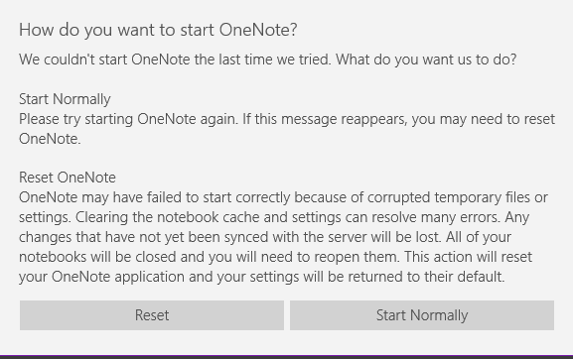

**Workaround:**

Use OneNote 2016 not OneNote for Windows.

**OneNote issues after the Microsoft update on MAC**

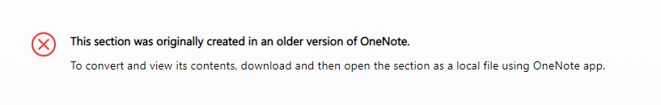

If notebooks have been created in an older version of OneNote, OneNote does not give the option to convert the notebooks.

**Workaround:**

Use a Windows device as it gives you option to convert to OneNote 2016, but it does not give that option on a MAC.

On a Windows device, in OneNote2016,

1 -Choose **File** – **Info**,

2 - then select **Properties**

3 - In the **Properties**, look for the default format to see what format the current notebook is saved in.

4 -To Upgrade an older version of notebook to the newer version, click Convert to 2010-2016

